

# Department of Electrical & Computer Engineering (ECE)

**Project- Individual Assignment Title:** Bank Management System **Course Title**: Database Systems

**Course Code:** CSE 311

# Submitted to:

Nadeem Ahmed (NDA) Senior Lecturer

# Submitted by:

**Name**: Sadik Munha

**Id: 1931437042**

**Section**: 07

**Dept:** ECE (CSE)

**Submission Date**: 18**.**09.2021

**Assignment Title**: Bank Management System

# Description:

Suppose, I own a Bank, and I have stored all the information in account details schema. There are six tables in the account details schema. Those tables are account, borrower, branch, customer, depositor, and loan.

## Account (account number, balance, branch name):

There is an account identified by account number. Total available balance at any given time represented by balance, and hosted branch name represented by branch name.

## Borrower (customer name, loan number):

Each customer can take a loan from the bank against the loan number. A loan number can assign to multiple borrowers. If the same loan number is assign to multiple borrowers, this will represent a joint loan against that loan number.

## Branch (branch name, branch city, asset):

A branch having a name is situate in a city having assets of a certain amount. There can be multiple branches in a city.

## Customer (customer name, Customer Street, customer city):

A customer having a valid name lives at a street address in a city.

## Depositor (account number, customer name):

A customer having a valid name has an account issued against an account number.

## Loan (loan number, branch name, and amount):

Loan number identifies each loan, and each loan is issue by branch having branch name. Amount represents the issued total loan by a branch.

# ER diagram:

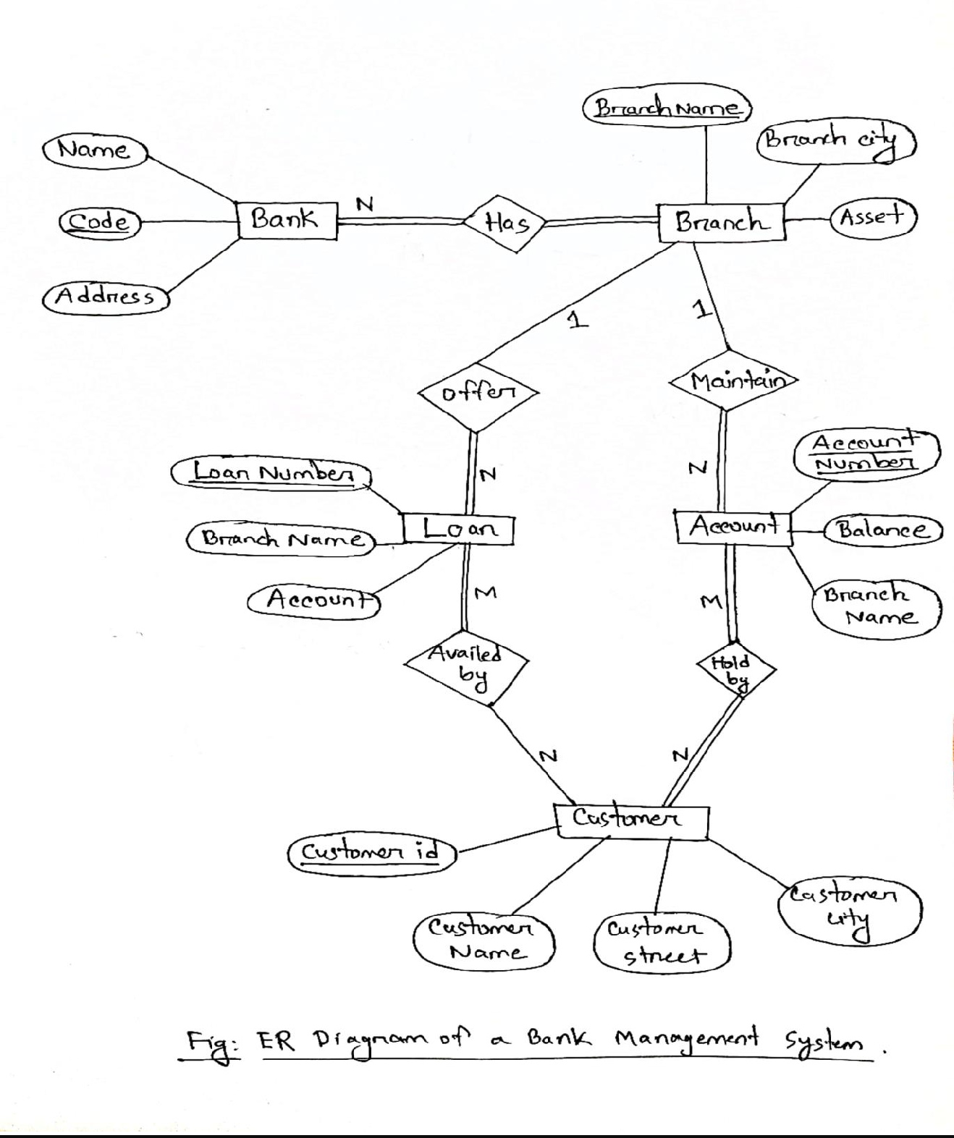

**Schema diagram:**

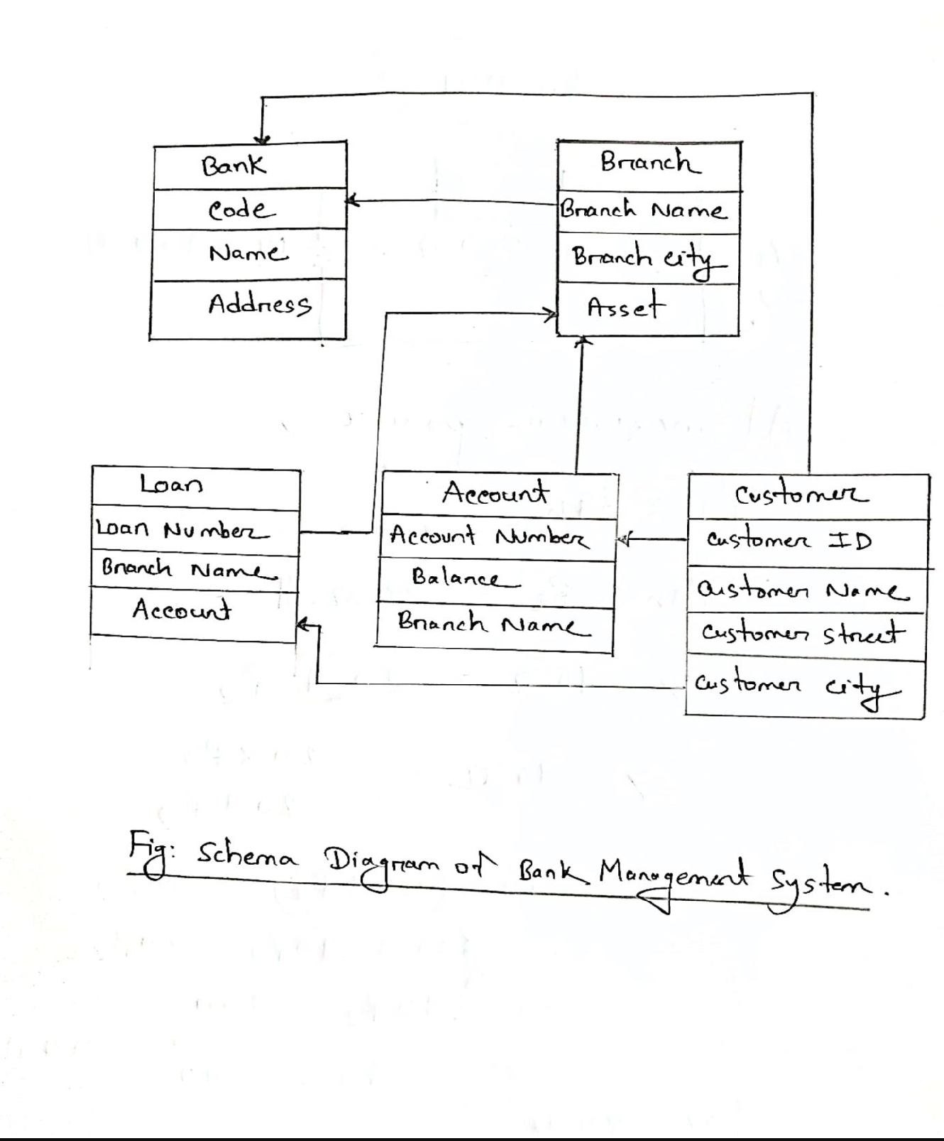

# Query of Chapter 3:

**Question:**

* Find out the customers’ name, customers’ city who have jointly borrowed a Loan.

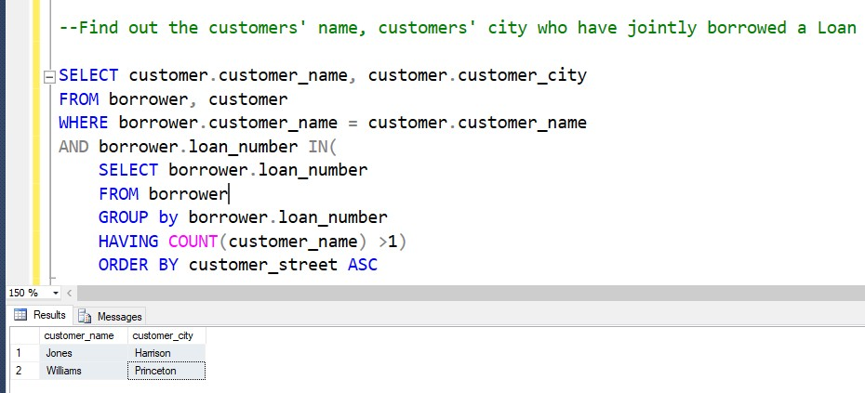

* Find out the Average deposited amount of the customers having a name that starts with ‘J’

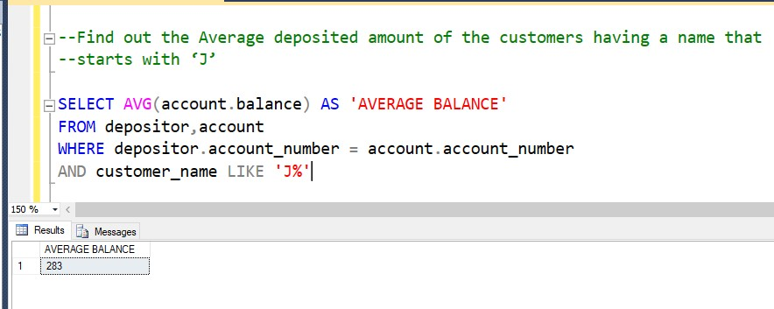

* List all the possible combinations of customer name and branch name. Sort the result based on the customer's name in descending order.

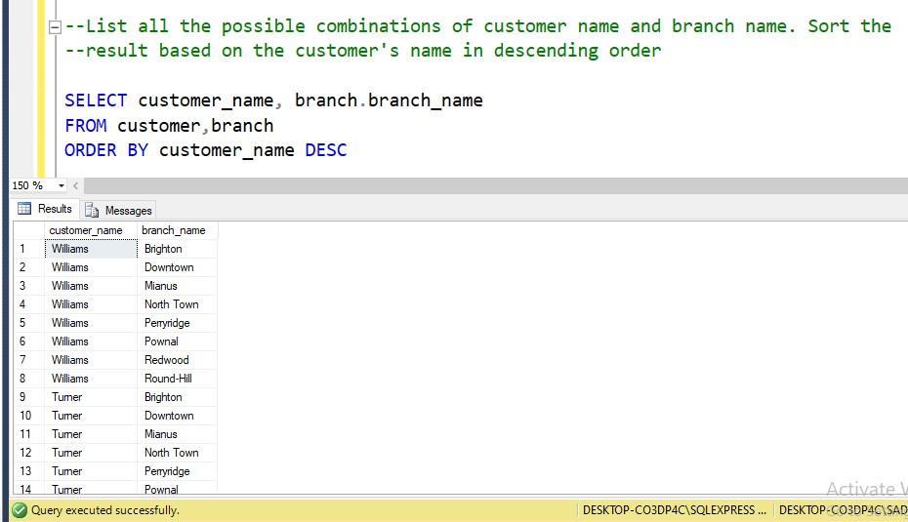

* Find out the customer’s details who does not have any deposit or loan account.

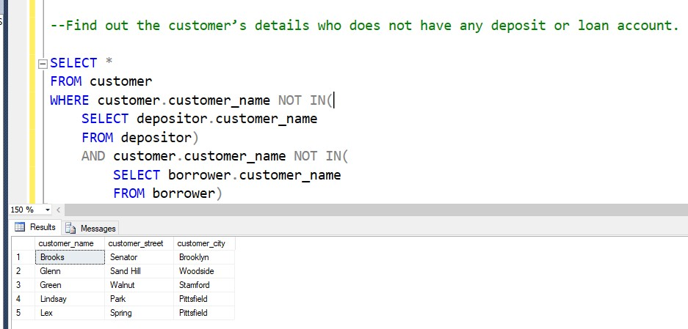

* Find out the Total Asset, Total Loan, and Total Deposit of your Bank.

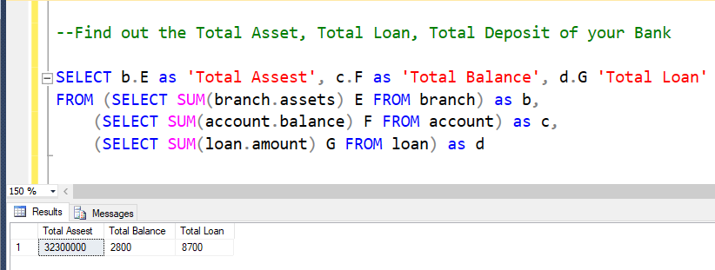

* Find out the customer name, street address, Account Number, Loan Number. Include the customer details also even if he/she does not have any deposit or loan account. Sort the result set in ascending order of customer name.

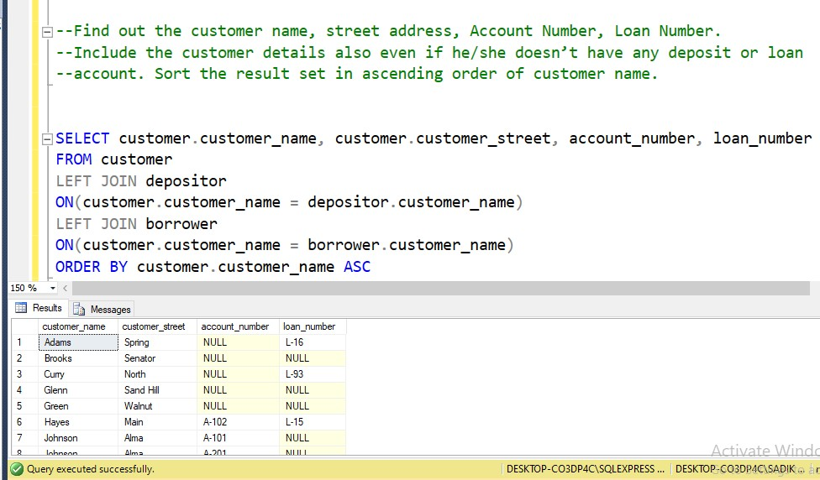

[NB: .SQL file is attached.]